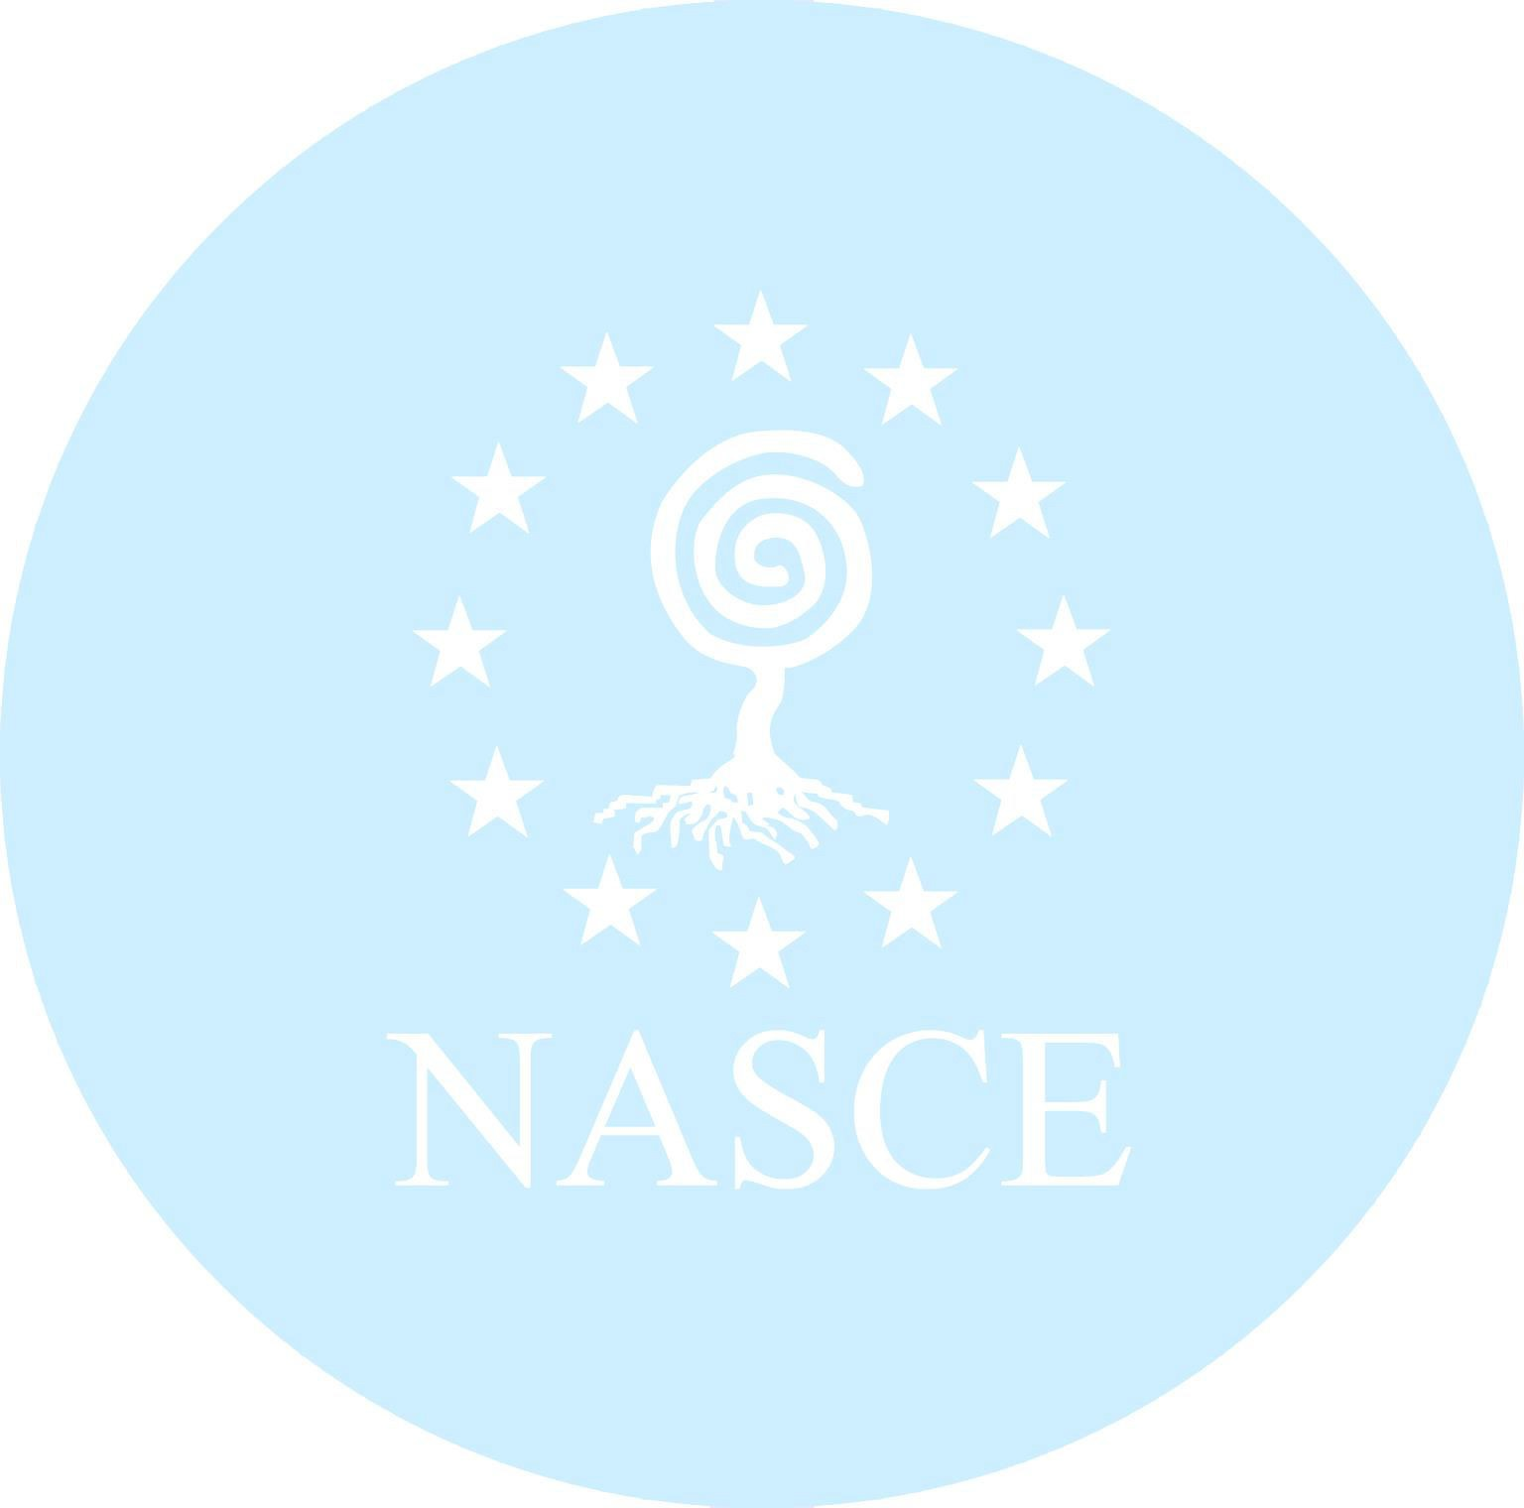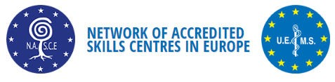

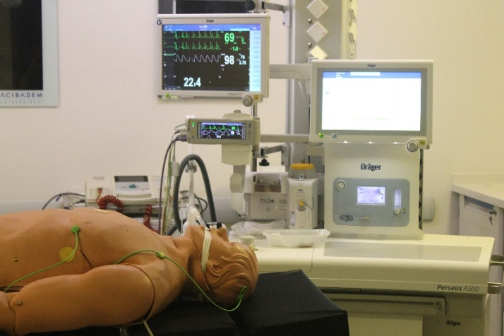

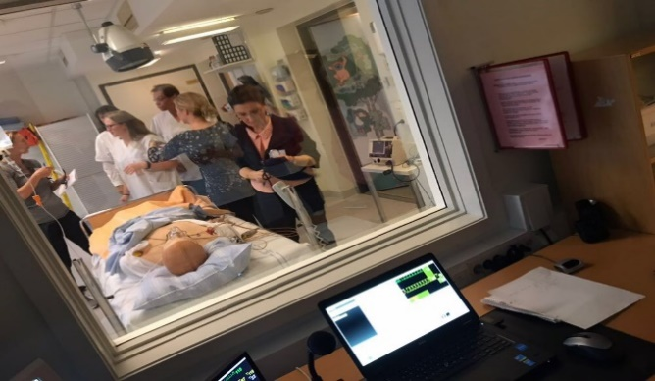

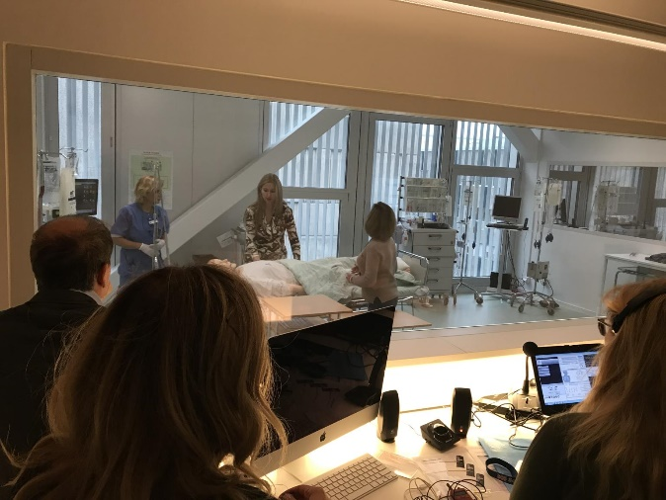

**Train the Trainer Course**

**The date for 2025 will be announced on NASCE website.**

# NASCE Train the Trainer Course

The multidisciplinary "Train the Trainer" course is designed for professionals from various fields who need to learn how to effectively use simulation-based training in their own centers.

# Who should attend?

* **Medical Educators**: Those who work in healthcare institutions to train medical professionals using clinical simulations (e.g., doctors, nurses, paramedics).
* **Simulation Lab Coordinators**: Personnel who oversee the setup and use of simulation equipment in healthcare or educational settings.

# Course Content

* Simulation Modalities
* Designing the medical simulation training program
* Programming technical skills training by using task trainers
* Basic principles of team trainings; communication skills, collaboration and decision making
* Preparing teamwork scenarios by using manikin-based simulators
* Assessment of technical skills and non-technical skills in a simulated environment
* Debriefing techniques

# Learning Outcomes

* By the end of the course participants will be able;
* To understand the principles of adult learning with simulation techniques,
* To choose the proper educational materials in simulated environments,
* To understand how to use task trainers and simulators for teaching technical skills,
* To understand the principles of scenario scripting and programming of the simulators according to learning outcomes,
* To understand the basic principles of debriefing techniques,
* To design courses for teaching both technical and nontechnical skills,
* To understand the basic principles of CRM for team trainings,
* To understand the basic principles of assessment in simulated environments.

# Course Fees

Certification: 650 € (450 € for participants from NASCE Accredited Centers)

Please contact Sandrine Tshimbulu-Tendu for payment procedure and other details:

[secretariat@uems.eu](mailto:secretariat@uems.eu)

*The number of participants for the course is limited 16-24 participants

# Course Agenda

# Day 1

|  |  |  |
| --- | --- | --- |
|  | | |
| 10:30-11:00 | *Welcome & Introduction* | ***Educator*** |
| 11:00-12:00 | *Simulation Modalities* | Dilek Kitapçıoğlu  *CASE Acibadem University*  Dara O’Keeffe  *Royal College of Surgeons of Ireland*  Cecilia Escher  *CAMST, Karolinska University* |
| 12:00-13:00 | **Lunch Break** |  |
| 13:00-14:00 | *Workshop 1*  *Programming technical skills training by using task trainers within small groups according to specialties/professions.* | Dilek Kitapçıoğlu  *CASE Acibadem University*  Dara O’Keeffe  *Royal College of Surgeons of Ireland*  Cecilia Escher  *CAMST, Karolinska University* |
| 14:00-15:00 | *Workshop 2*  *Assessment of technical skills and non-technical skills in a simulated environment* | Dilek Kitapçıoğlu  *CASE Acibadem University*  Dara O’Keeffe  *Royal College of Surgeons of Ireland*  Cecilia Escher  *CAMST, Karolinska University* |
| 15:00-16:00 | *CRM (Crisis Resource Management)*  *Lecture*  *Basic principles of team trainings;*  *communication skills, collaboration and decision making* | Dilek Kitapçıoğlu  *CASE Acibadem University*  Dara O’Keeffe  *Royal College of Surgeons of Ireland*  Cecilia Escher  *CAMST, Karolinska University* |

# Course Agenda

# Day 2

|  |  |  |
| --- | --- | --- |
|  | | |
| 09:30-10:30 | *Debriefing techniques*  *Lecture* | ***Educator***  Dilek Kitapçıoğlu  *CASE Acibadem University*  Dara O’Keeffe  *Royal College of Surgeons of Ireland*  Cecilia Escher  *CAMST, Karolinska University* |
| 10:30-10:45 | **Coffee Break** |  |
| 10:45-12:00 | *Preparing teamwork scenarios by actively involving the participants as trainers/learners within groups* | Dilek Kitapçıoğlu  *CASE Acibadem University*  Dara O’Keeffe  *Royal College of Surgeons of Ireland*  Cecilia Escher  *CAMST, Karolinska University* |
| 12:00-13:00 | **Lunch Break** |  |
| 13:00-16:00 | *Workshop 3*  *Observers/educators/learners*  *Running simulation sessions with in small groups according to specialties/professions.*   * *Prebriefing* * *Familiarization* * *Scenario* * *Debriefing* | Dilek Kitapçıoğlu  *CASE Acibadem University*  Dara O’Keeffe  *Royal College of Surgeons of Ireland*  Cecilia Escher  *CAMST, Karolinska University* |
| 16:00-17:00 | *Certificates* |  |



# Previous Courses

Participants of this interactive course were multi-disciplinary teams of physicians, nurses and other advanced care providers from different field such as Anesthesiology, Intensive care, General surgery, Neurosurgery, Cardiovascular Surgery, Orthopedic Surgery, Obstetrics Gynecology, Emergency Medicine, Internal medicine, Gastroenterology, Cardiology.

The number of trainees who have participated in the courses since 2017:

Countries: Greece, Lithuania, Ukraine, Bulgaria, Denmark, Sweden, Turkey, France, Georgia, Belgium, Finland, Switzerland, Ireland, Croatia, Germany.

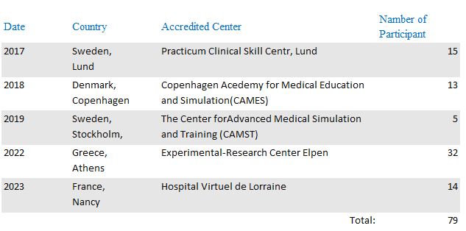

You can find detailed information about the course on NASCE webpage

**www.uemsnasce.eu**